Data SET

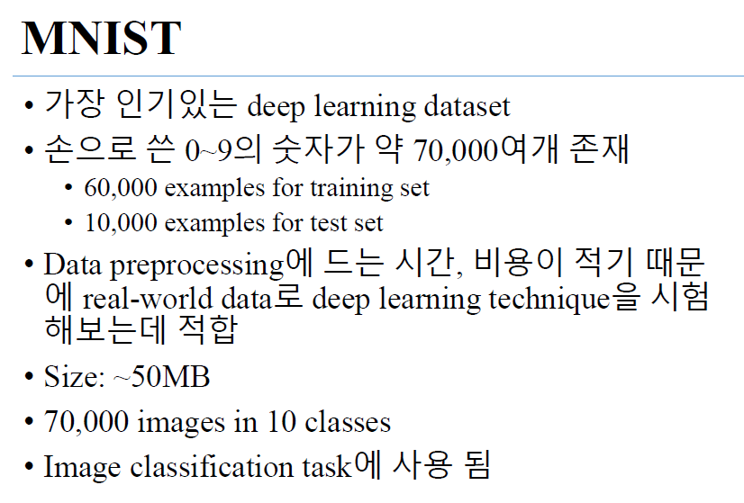

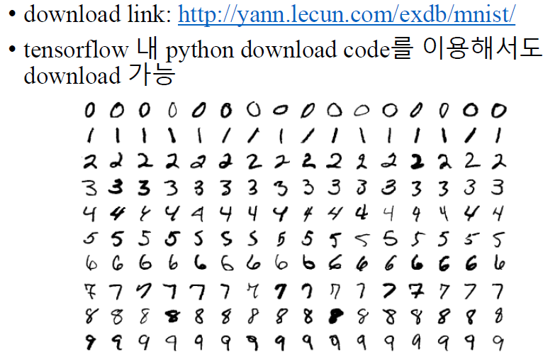

<http://yann.lecun.com/exdb/mnist/>

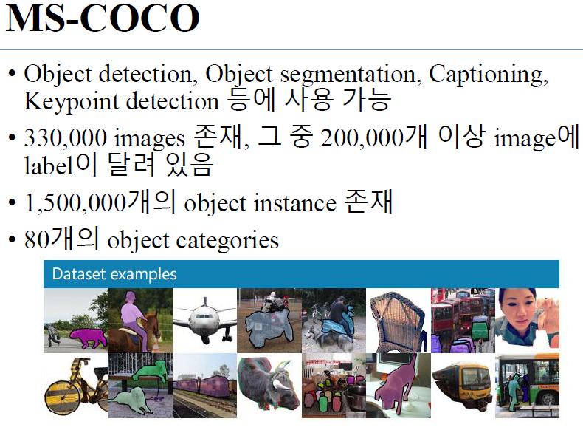

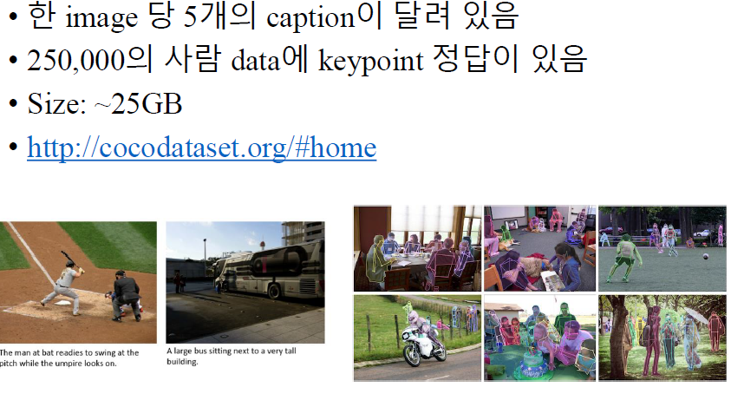

[http://cocodataset.org/#home](http://cocodataset.org/%23home)

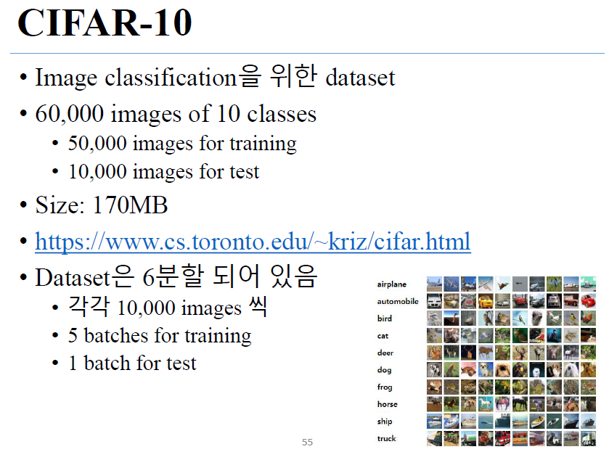

<https://www.cs.toronto.edu/~kriz/cifar.html>

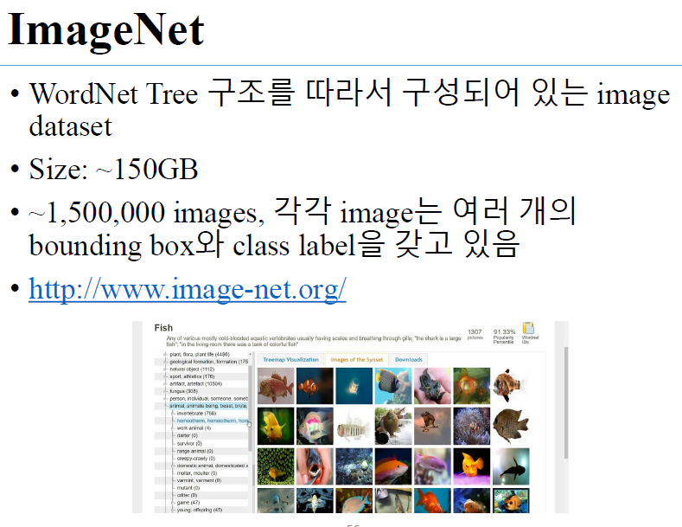

<http://www.image-net.org/>

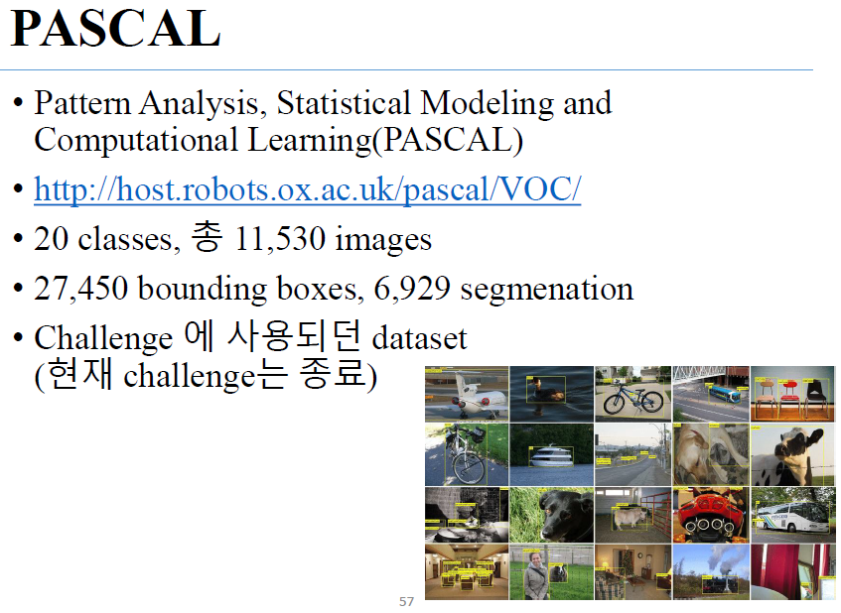

<http://host.robots.ox.ac.uk/pascal/VOC/>

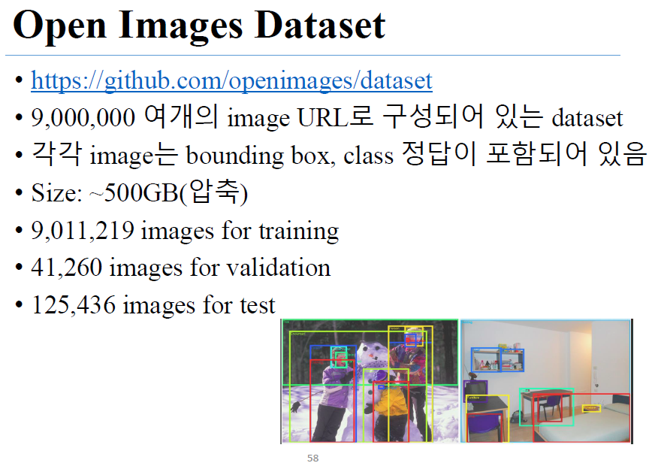

<https://github.com/openimages/dataset>

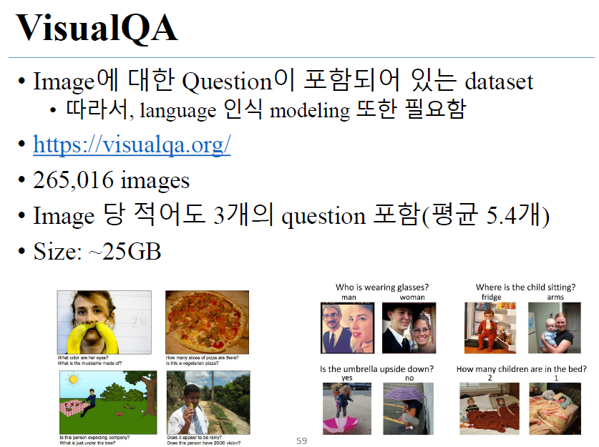

<https://visualqa.org/>

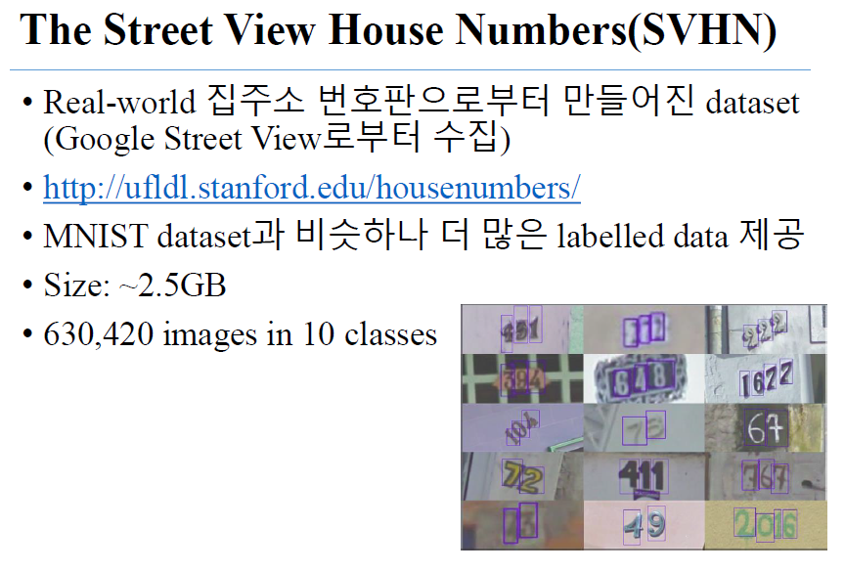

<http://ufldl.stanford.edu/housenumbers/>

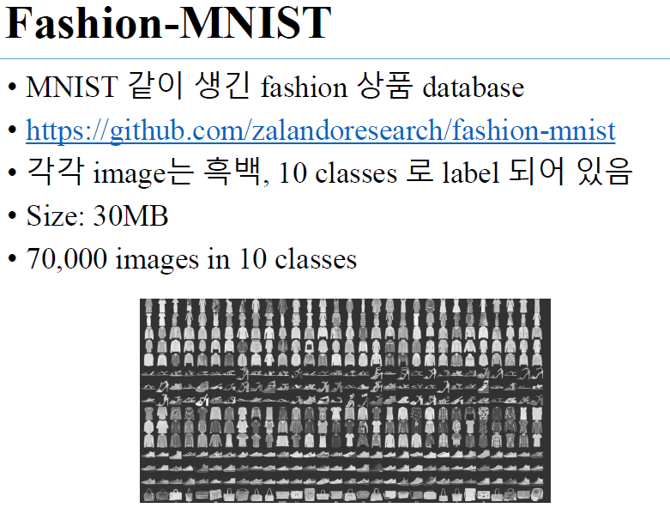

<https://github.com/zalandoresearch/fashion-mnist>